**Question 1:**

1. The iteration ‘i’ needs data processed in a previous step ‘I – 1’
2. One can use the Parallel Scan strategy to solve this data-dependency pattern.

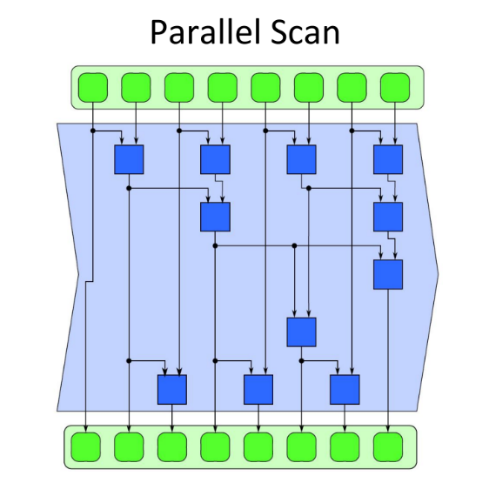Compute even iterations. Then keep using those processed iterations nodes to fix the even ones that needs computation to be done. At the end, compute the odd iterations that needs processing (node one, per example, doesn’t need further processing).

**Question 2:**

**The answer to this question can be found in life.cc**

1. Parallel Scan and 2D Stencil

**Question 3:**

**The answer to this question can be found in shear.cc**